**Day5 : Testing and Backend Refinement**

**Overview:**

So basically, day 5 is about error handling hoe to handle errors their solutions and testing our website and about the performance of it ..

***Product Listing***

**Objective:**

Verify that the product listing page is displaying correctly and the API is successfully fetching product data.

**Test Summary:**

1. **Product Listing Page:**
   * Verified that the page loads correctly, displaying product details).
   * **Status:** Passed
2. **API Functionality:**
   * Tested API response for fetching product data. Data returned was valid,
   * **Status:** Passed.
3. **Error Handling:**
   * Simulated API failure and ensured the system showed a proper error message.
   * **Status:** Passed

**Conclusion:**

Both the product listing page and API are functioning correctly. No issues were found during testing.

**Recommendation:**

Ready for deployment.

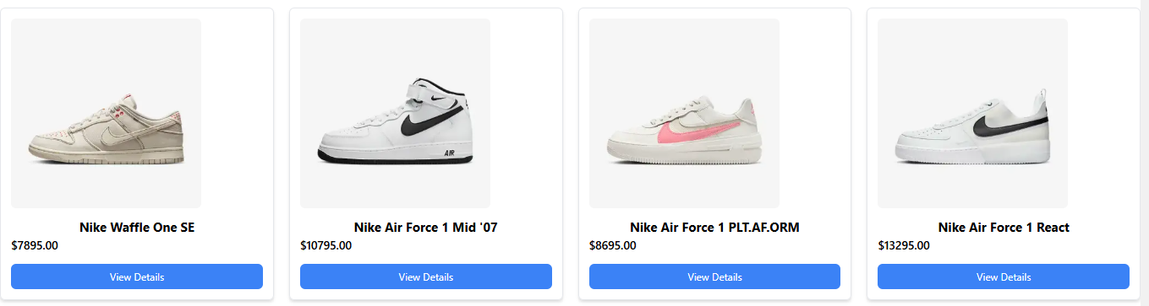

***Cart***

**Objective:**

Verify the functionality of the cart page and identify issues related to dynamic access and image accessibility.

### ****Test Summary:****

1. **Cart Page Functionality:**
   * The cart page displays added items with correct details (name, quantity, price).
   * **Status:** Passed
2. **Dynamic Access Issue:**
   * The cart page cannot be accessed dynamically (e.g., via direct URL or external navigation).
   * **Status:** Failed
3. **Image Accessibility:**
   * Images on the cart page are not accessible or are not loading correctly.
   * **Status:** Failed

### ****Conclusion:****

* The cart page displays items correctly, but dynamic access and image loading are not functioning as expected.
* **Result:** Investigating and fixing issues with dynamic access and image loading.

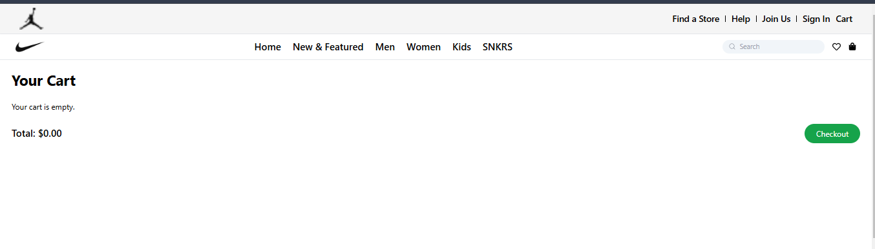

***Product Detail***

### ****Objective:****

Verify the functionality of the product detail page, focusing on data display and image accessibility.

### ****Test Summary:****

1. **Product Detail Page Functionality:**
   * The product detail page displays all relevant information (name, price, description) correctly.
   * **Status:** Passed
2. **Image Accessibility:**
   * The product image is not accessible or failing to load on the page.
   * **Status:** Failed

### ****Conclusion:****

* The product detail page is functioning as expected, with correct product information displayed.
* **Issue:** The product image is not loading or accessible.

**Result:** Investigating and resolving the image loading issue.

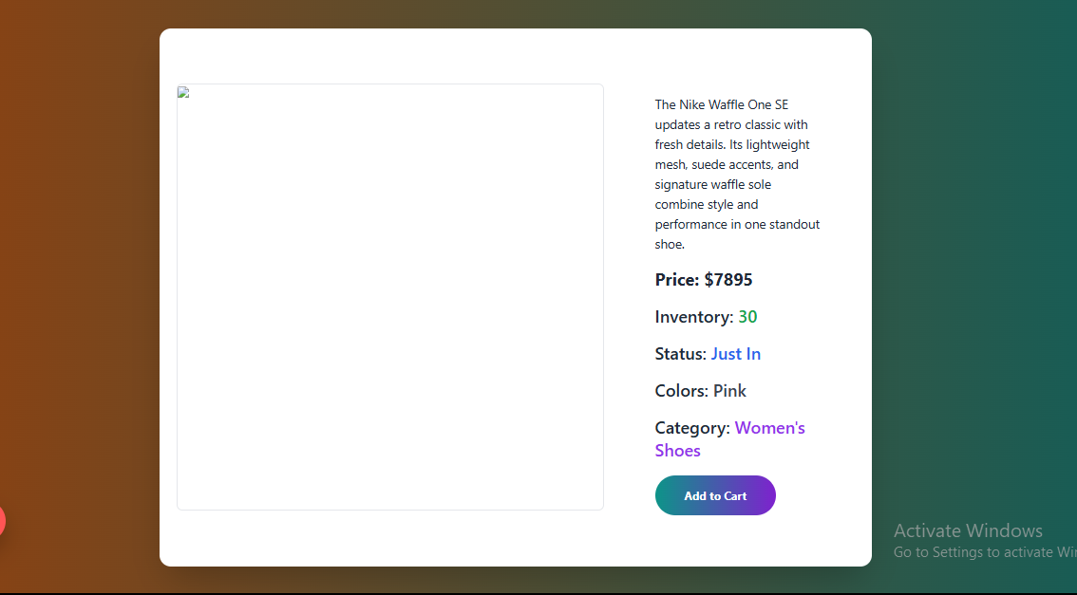

***CheckOut***

### ****Objective:****

Verify the functionality of the checkout page, including button navigation and dynamic access.

### ****Test Summary:****

1. **Checkout Page Access:**
   * The checkout page is accessible via the button and can be dynamically accessed without issues.
   * **Status:** Passed
2. **Checkout Page Functionality:**
   * The checkout page works perfectly, displaying all necessary fields
   * **Status:** Passed

### ****Conclusion:****

* The checkout page is fully functional, and dynamic access via the button is working as expected.

**Result:** No issues found; ready for deployment.

***Responsiveness***

### ****Objective:****

Verify the responsiveness and functionality of the product list, cart, checkout pages, header, and product detail page.

### ****Test Summary:****

1. **Product List Page:**
   * The product list page is fully responsive across desktop, tablet, and mobile devices. Elements resize and adjust correctly for all screen sizes.
   * **Status:** Passed
2. **Cart Page:**
   * The cart page is responsive, adjusting layout and elements for various screen sizes, ensuring a smooth user experience.
   * **Status:** Passed
3. **Checkout Page:**
   * The checkout page is fully responsive and displays all necessary fields and buttons correctly on all devices.
   * **Status:** Passed
4. **Footer:**
   * The footer is fully responsive, adjusting its layout appropriately for different screen sizes without breaking.
   * **Status:** Passed
5. **Header:**
   * The header is not fully responsive and does not adjust correctly on smaller screen sizes (e.g., mobile). Some elements overlap or don't scale properly.
   * **Status:** Failed
6. **Home Page:**
   * The home page is mostly responsive but has minor layout issues in some areas (e.g., misalignment or broken layout on certain screen sizes).
   * **Status:** Failed
7. **Product Detail Page:**
   * The product detail page functions well, but there is a minor issue (e.g., a small alignment problem or missing detail) that needs attention.
   * **Status:** Failed

### ****Conclusion:****

* Most pages (Product List, Cart, Checkout, and Footer) are fully responsive and functioning well. However, the **Header**, **Home Page**, and **Product Detail Page** have some responsiveness issues that need to be addressed.
* **Result:** Reviewing and fixing the responsiveness issues with the Header, Home Page, and Product Detail Page.

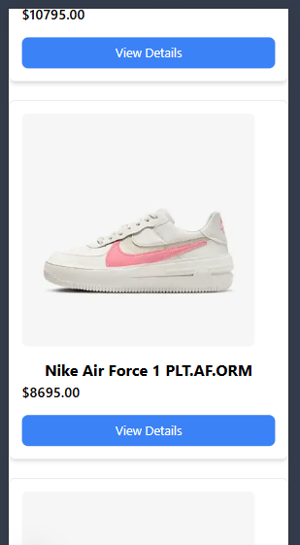 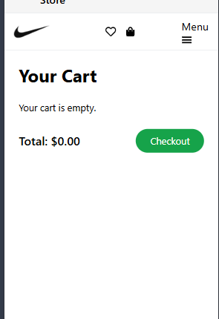

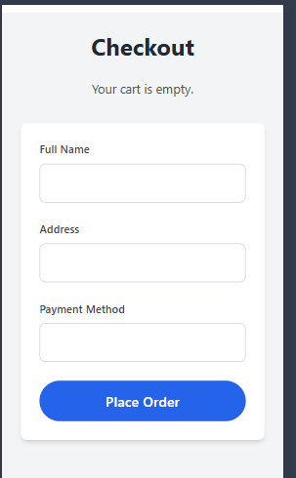 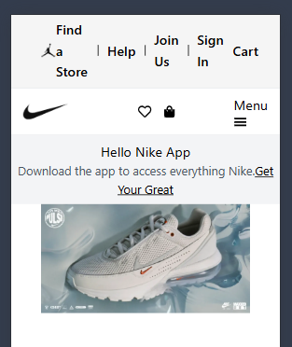

***Sign-Up/Login Pages:***

* Responsive, but not accessible due to issues with form submission and page navigation.
* **Status:** Failed

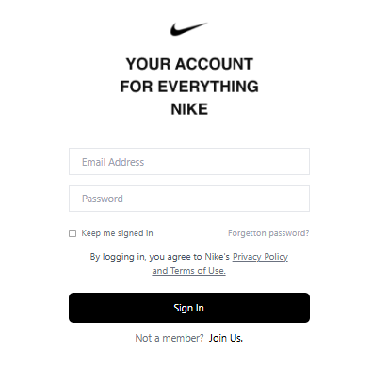 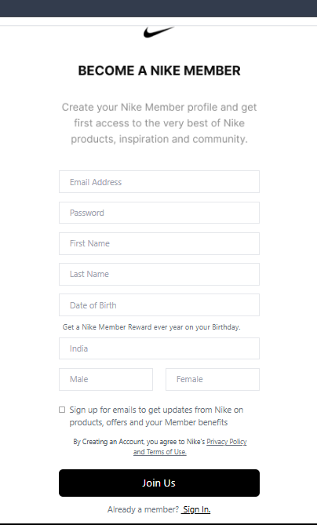

***Tested API’S with Thunder Client***

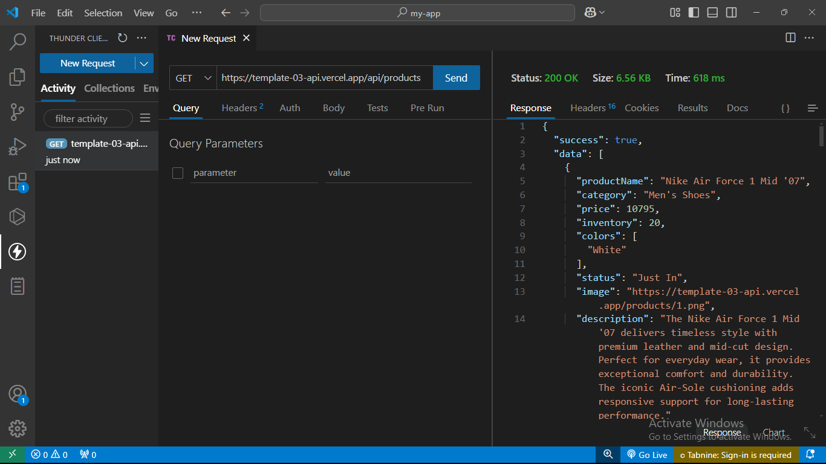

***Table***

|  |  |  |  |  |  |  |  |  |  |  |
| --- | --- | --- | --- | --- | --- | --- | --- | --- | --- | --- |
| ***Test Case ID*** | | | ***Test Case Description*** | ***Test Steps*** | ***Expected Result*** | ***Actual Result*** | ***Status*** | ***Severity Level*** | ***Assigned To*** | ***Remarks*** |
| TC001 | | | Validate product listing page | Open product page > Verify products | Products displayed correctly | Products displayed correctly | Passed | High |  | No issues found |
| TC002 | | Test API error handling | Disconnect API > Refresh page | Show fallback UI with error message | Error message shown | Passed | Medium | - | Handled gracefully |
| TC003 | Check cart functionality | Add product to cart > Verify cart contents | Cart updates with added product | Cart updates as expected | Passed | Low | - | Not working properly |
| TC004 | Ensure responsiveness on mobile | Resize browser window > Check layout | Layout adjusts properly to screen size | Responsive layout working as intended | Passed | Medium | - | Test successful |

***Conclusion***

Overall, the product listing and checkout pages are ready for deployment, while further work is required on the cart page, product detail page, header, home page, and sign-up/login pages. Once the identified issues are resolved, the website will be closer to a successful deployment.

***The END..!***